**Technological Institute of the Philippines**

938 Aurora Blvd., Cubao, Quezon City

**College of Engineering and Architecture**

Electronics Engineering Department

Homewrok II

**NEURAL STYLE TRANSFER**

Submitted by:

**Gabotero, Clive Jake A.**

ECE41S1

Submitted to:

**Engr. Christian Lian Paulo P. Rioflorido, MSEE**

October 2022

In this Neural Style Transfer activity, I used pretrained models from the TensorFlow Hub and thus it is broadly elaborated in this paper how optimization is applied on output images while blending two input images. On the first image blending or style transfer, I used the image of the TechnoCore building in the Technological Institute of the Philippines Quezon City as the content image and Juan Luna’s Spolarium as the styling image. And on the second style transfer, I used the same picture of the content image but with Leonardo Da Vinci’s The Battle of Anghiari as the styling image.

**Style Transfer 1 (TechnoCore building + Juan Luna’s Spolarium):**

To start the Neural Style Transfer, it is important to load the necessary libraries.

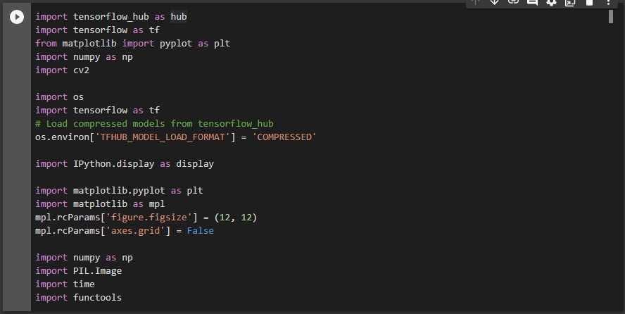

In these next lines of code, the tensor is being set up while the content image and the style image is loaded up from the google drive.

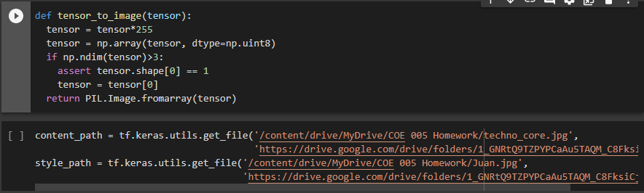

Then, we make sure that the imported images are what we wanted to import by plotting them. We first define the dimensions and convert the type of image into float for the program to be able to plot the image.

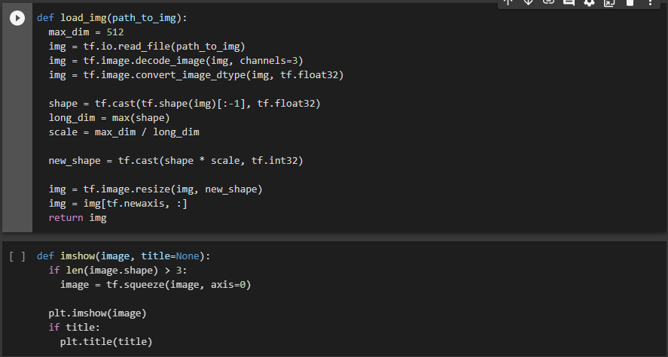

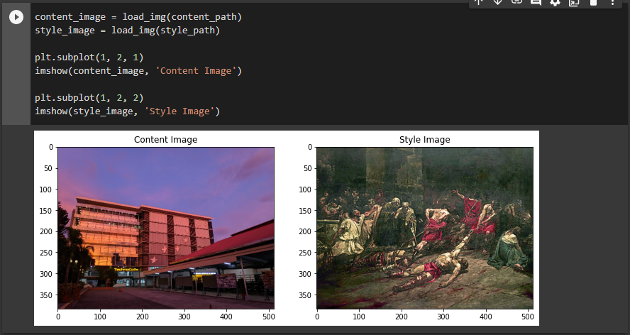

From the lines of codes above, we have successfully plotted and checked the images that we have loaded. The content image being the TechnoCore building and the style image as the spolarium. Now we are going to define the content and style representations of the image. Load the VGG19 and test run it on our image to ensure its use.

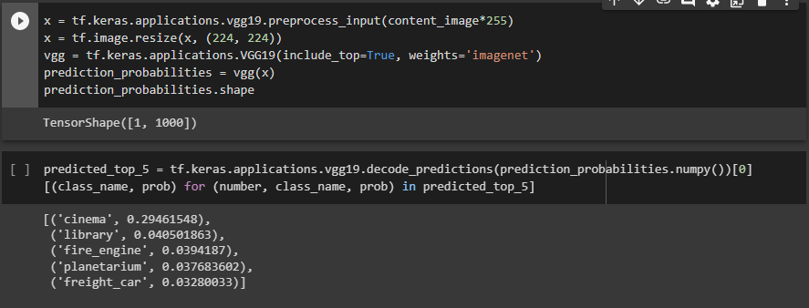

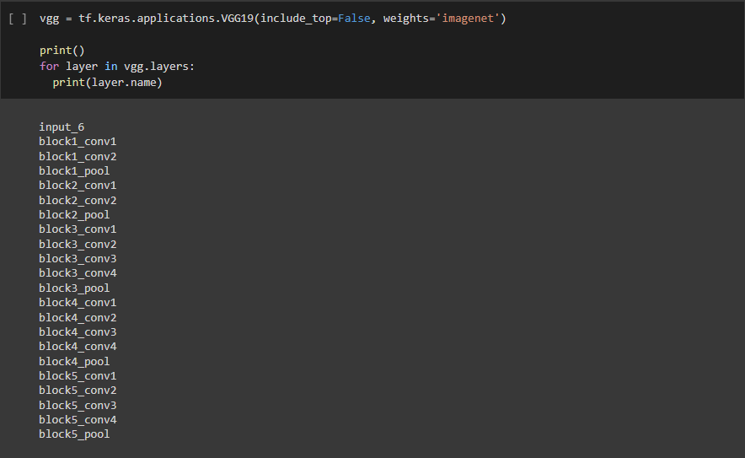

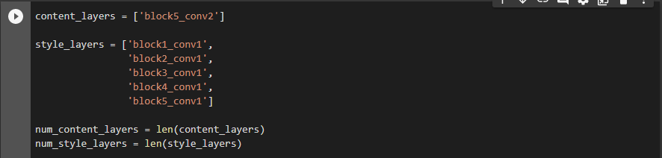

To determine the representation of content and style from the images, these intermediary layers are required. At these intermediate levels, we match the corresponding style and content target representations for an input image.

Now it is time to build the model. We first specify the inputs and outputs in defining a model using the functional API and builds a VGG19 model which returns a list of layers.

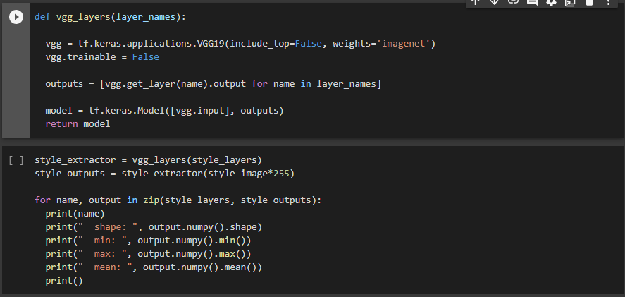

And the output list of layers:

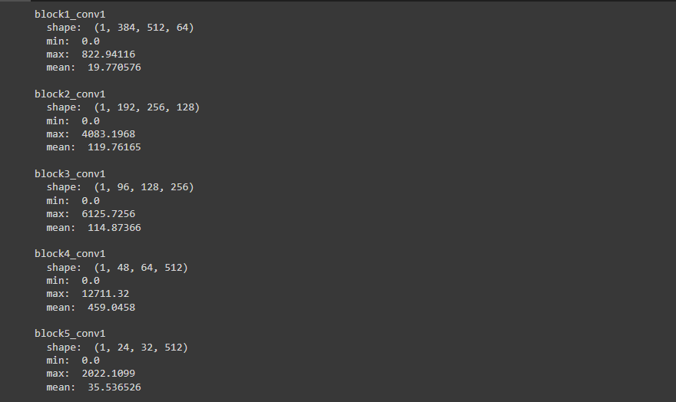

Using the tf.linalg.einsum function, calculating the Gram matrix in describing the style of the image can be achieved.

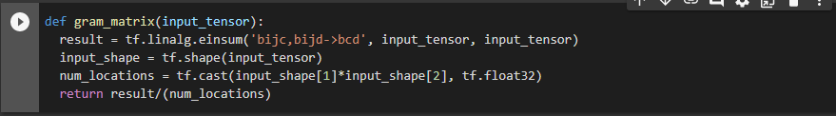

Now we extract the content and the style tensors using these next lines of codes.

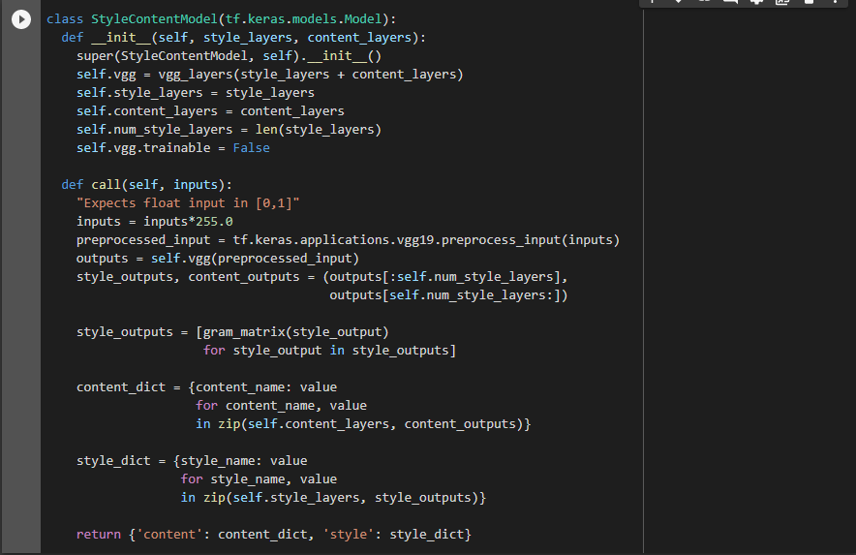

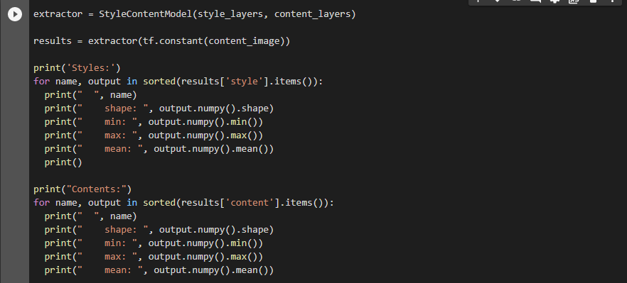

Therefore, the tensor representations are as follows.

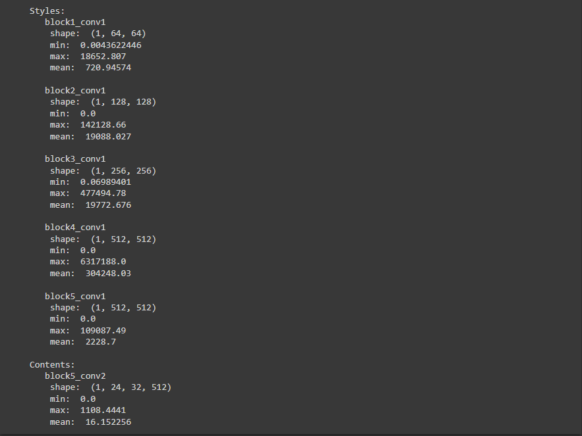

With the style and content extracted, we can implement the style transfer algorithm by calculating the mean square error for the image’s output then we create an optimizer using the weighted losses to get the total loss.

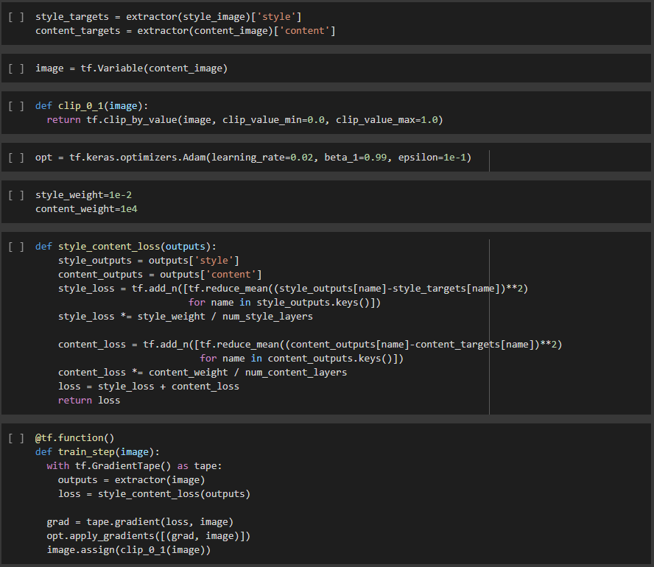



Then we test and see an output image.

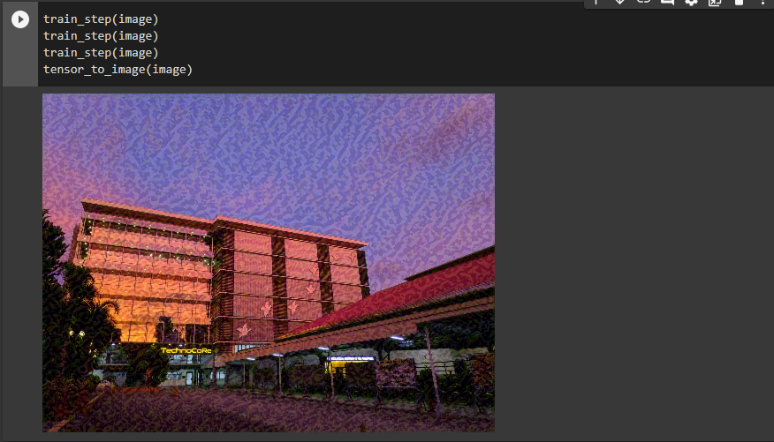

We can therefore perform a longer optimization since the algorithm is working.

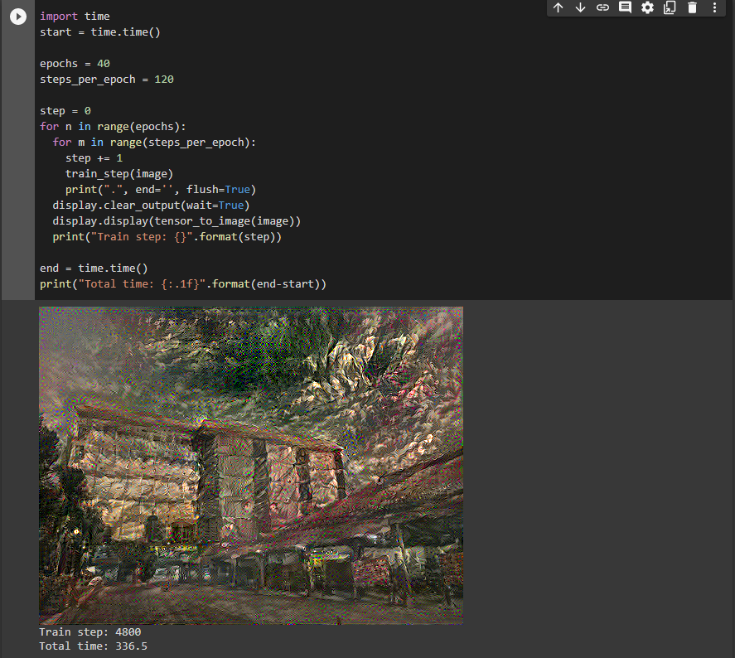

With this output, we can obtain the variation loss from the following lines of codes.

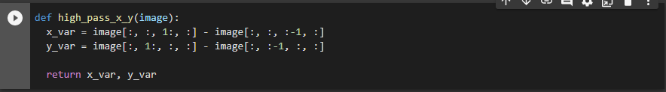

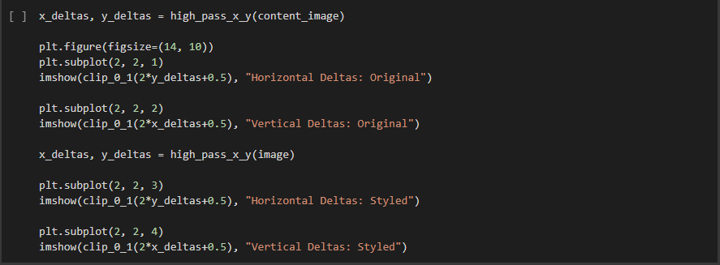

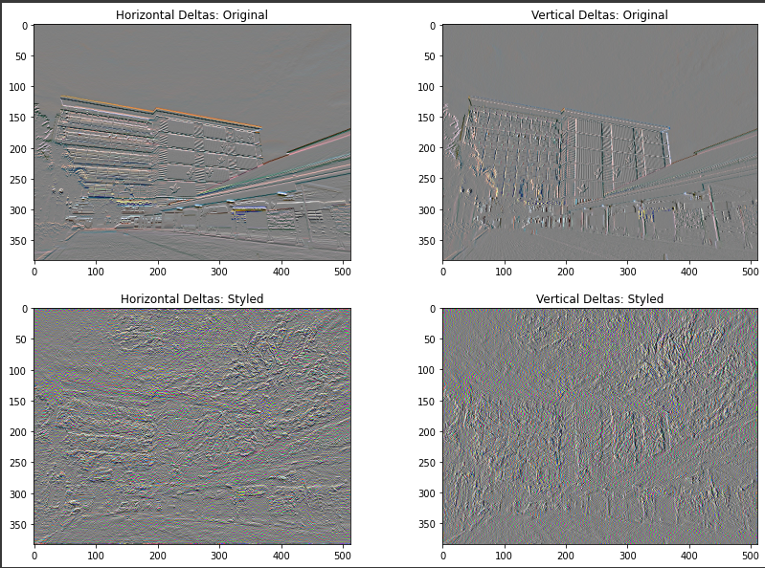

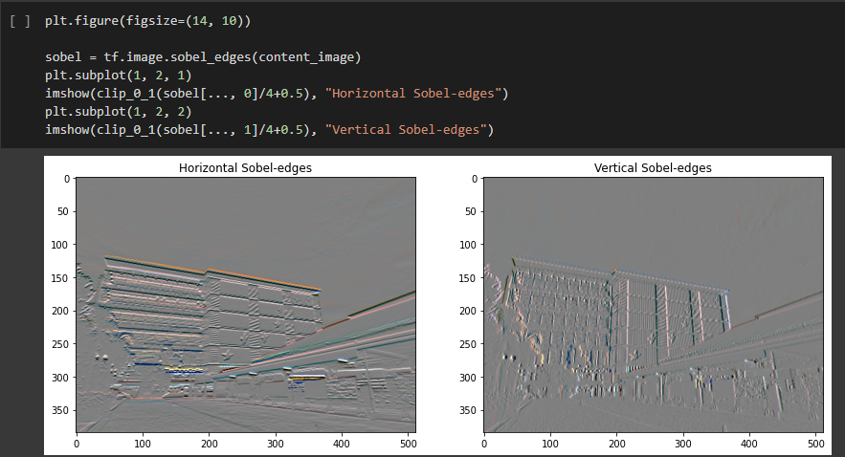



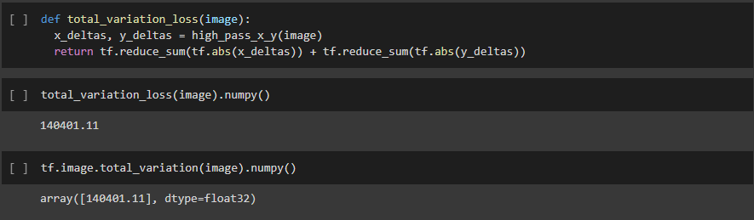

Now we must re-run the optimization using a weigh for the total variation loss to obtain a better output.

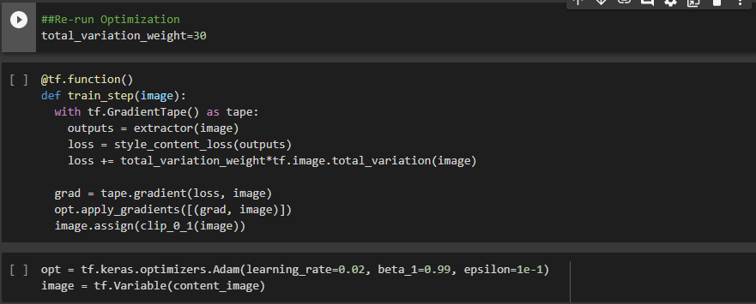

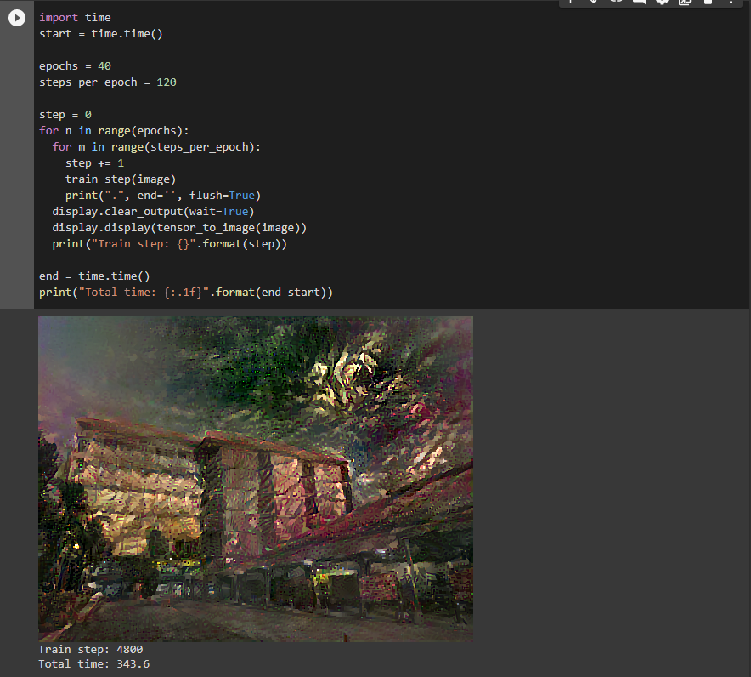

**Style Transfer 2 (TechnoCore building + Leonardo Da Vinci’s The Battle of Anghiari):**

For the second style transfer, the same algorithm or codes with the first style transfer have been used. The only difference is that the style image used is Leonardo Da Vinci’s The Battle of Anghiari. Shown below are the lines of codes showing the content, style, and finally the output images.

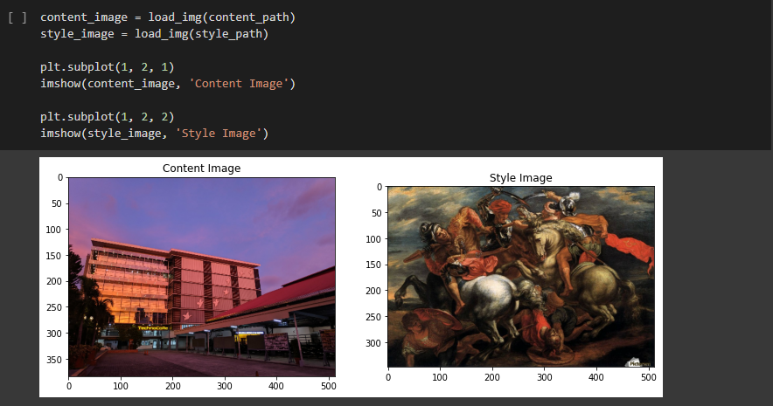

First test run:

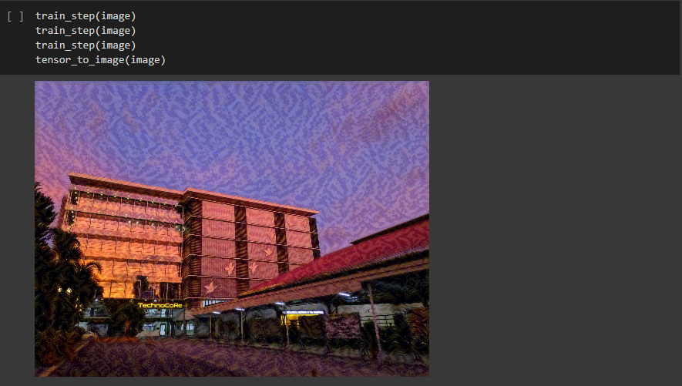

Prolonged Optimization:

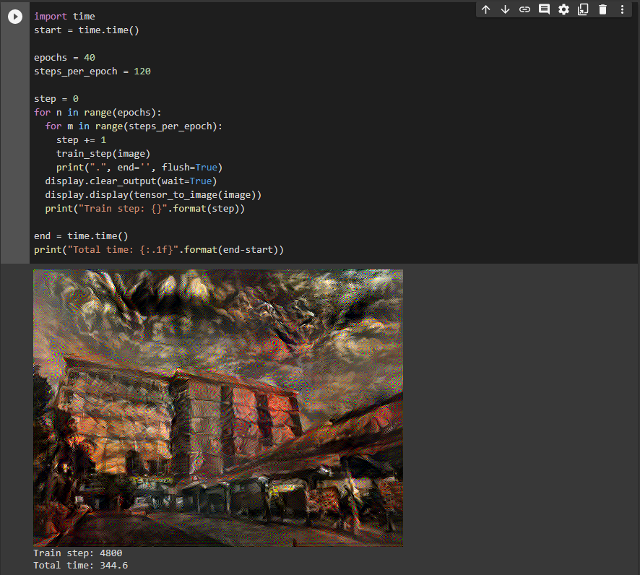

Final output with a specified total variation loss of 30:

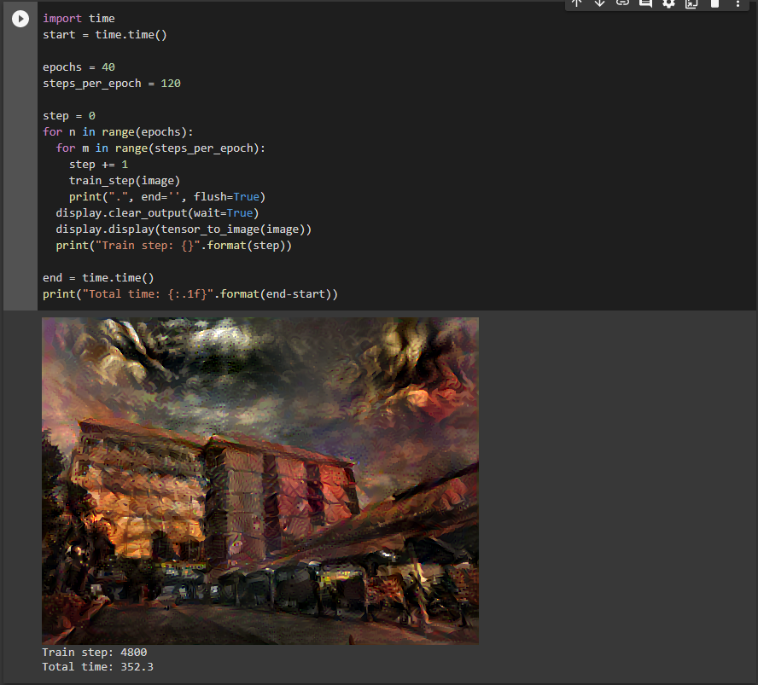

**Conclusion:**

In this activity, I have learned how the Neural Style Transfer works and how painting styles of famous artists can be applied on a digitally captured image. Shown below are the content images, style images, and the resulting images obtained from the two Style Transfers:

**Style Transfer 1:**

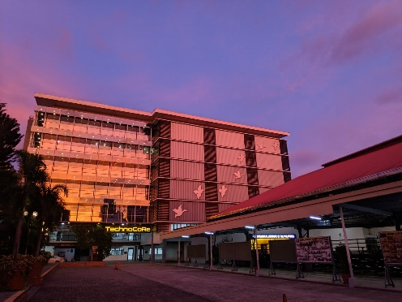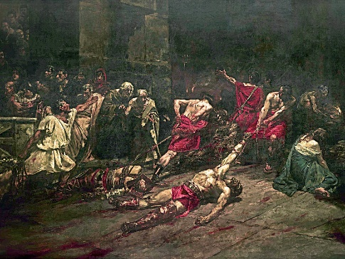

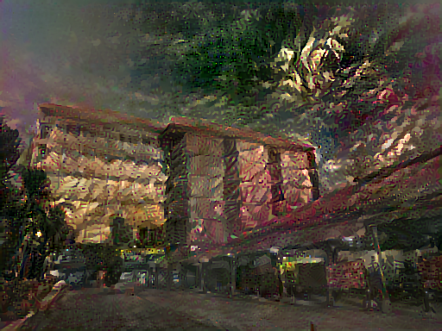

Output Image

**Style Transfer 2:**

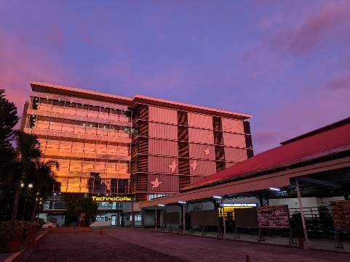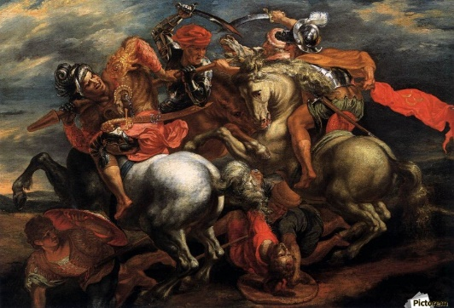

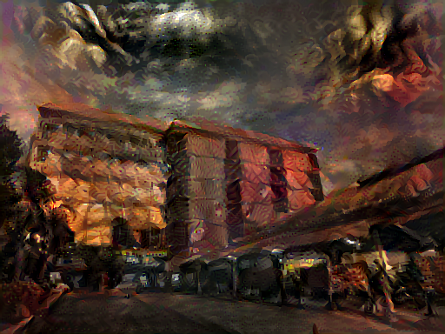

Output Image